

**MISSION HACKERS**

**BANGLADESH**

**Assignment No-01**

**Assignment Title: Kali Linux Terminal Commands**

**Course Title : Ethical Hacking**

**Submitted by:**

**Name: Istiak Alam**

**Phone : 01765376101**

**Submission Date: 08-07-25**

**Lab Task Topic : Familiarization of Linux Commands**

**Submitted to:**

**MD Sha Jalal**

**Founder of Mission Hackers Bangladesh**

* **Objective :**

The objective of this assignment is to develop foundational proficiency in using the Kali Linux terminal for Cybersecurity and ethical hacking tasks. Students will learn and apply essential command-line operations to navigate the file system, manage files and directories, monitor system processes, and perform network-related tasks. By mastering these basic commands, students will gain the practical skills necessary to operate efficiently in a Linux-based penetration testing environment, which is critical for conducting real-world ethical hacking and security assessments.

* **Introduction :**

Kali Linux is a Debian-based distribution specifically designed for penetration testing and security auditing. Unlike traditional graphical user interfaces, many of Kali’s powerful tools are executed from the terminal, making command-line proficiency a critical skill for any Cybersecurity professional. This assignment focuses on commonly used Linux terminal commands to help students become comfortable with the Linux environment and prepare them for more advanced ethical hacking tasks.

* **Kali Linux Terminal Commands :**
  1. **Creating Files using terminal**

Syntax : touch file_name

Command : $ **touch Passwd.txt**

Sample Input & Output :

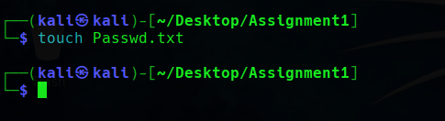

* 1. **Creating Folder using terminal**

Syntax : mkdir directory_name

Command : $ **mkdir Assignment1**

Sample Input & Output :

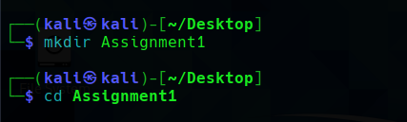

* 1. **Print Working Directory using terminal**

Syntax : pwd

Command : $ **pwd**

Sample Input & Output :

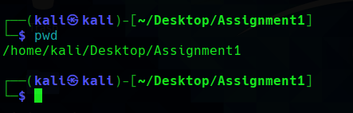

* 1. **Change Directory using terminal**

Syntax : cd directory_name

Command : $ **cd Assignment1**

Sample Input & Output :

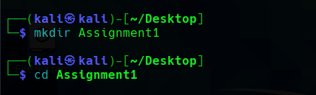

* 1. **Print Content using terminal**

Syntax : cat file_name

Command : $ **cat Passwd.txt**

Sample Input & Output :

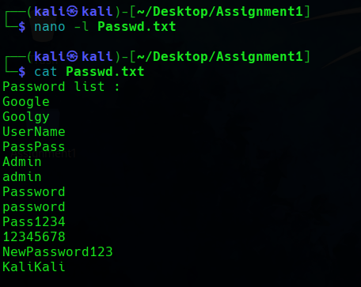

* 1. **Text Editor using terminal**

Syntax : nano file_name

Command : $ **nano -l Passwd.txt**

Sample Input & Output :

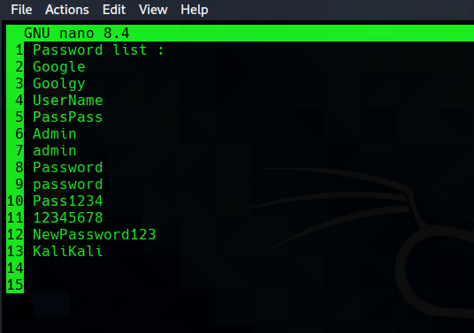

* 1. **Print List of all special dot files in a directory.**

Syntax : ls -a

Command : $ **ls -a**

Sample Input & Output :

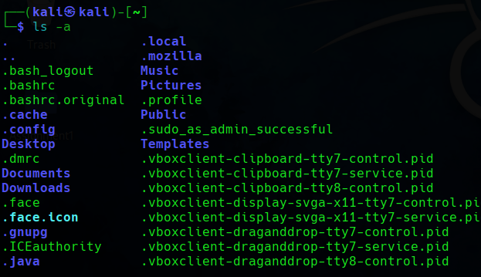

* 1. **Print Long List of files in a directory.**

Syntax : ls -l

Command : $ **ls -l**

Sample Input & Output :

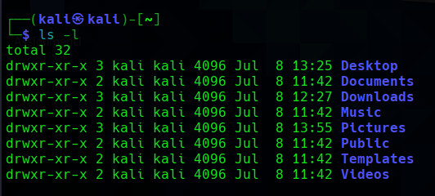

* 1. **Print size of files in human readable form of a directory.**

Syntax : ls -l -h

Command : $ **ls -l -h**

Sample Input & Output :

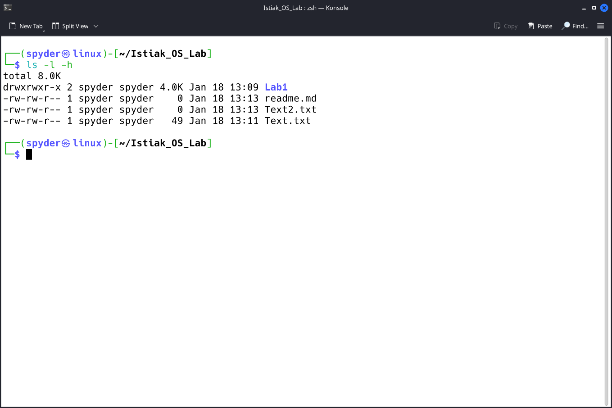

* 1. **Mark all the Executable files & Folder form of a directory.**

Syntax : ls -F

Command : $ **ls -F**

Sample Input & Output :

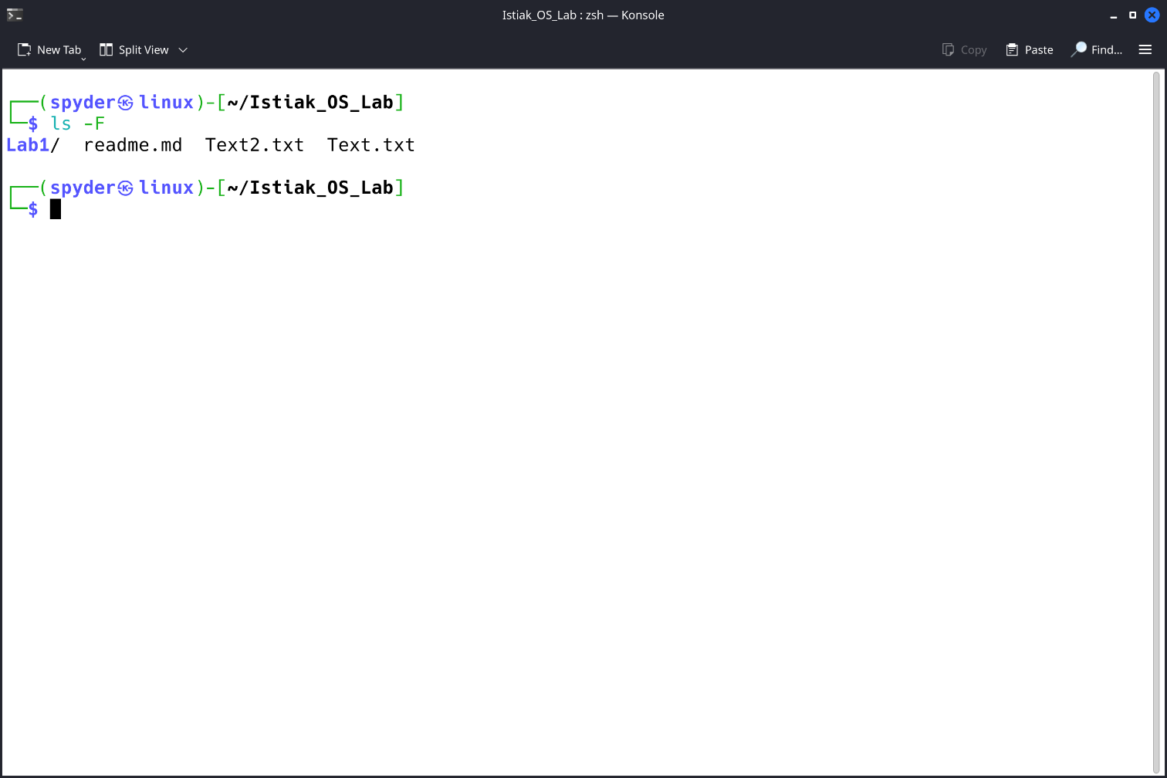

* 1. **Copy files & Directory using terminal.**

Syntax : cp [option] file1 file2

Command : $ **cp Text.txt Copied.txt**

Sample Input & Output :

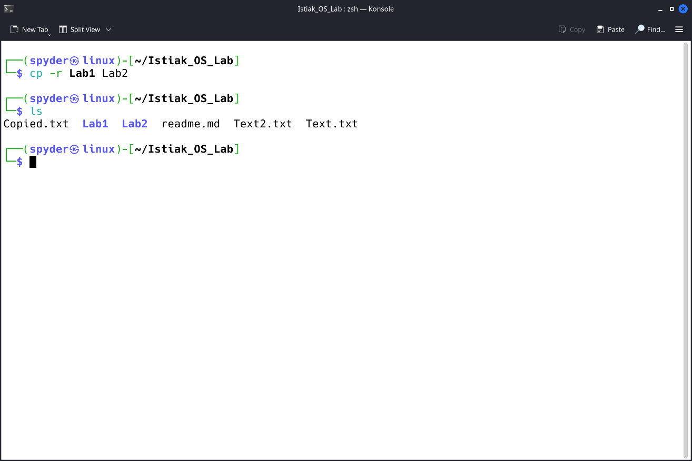

* 1. **Remove or Delete files & Folder Using terminal.**

Syntax : rm file_name //removing a file

Syntax : rmdir directory_name //removing a folder

Command : $ **rm Text2.txt**

Command : $ **rmdir Text2.txt**

Sample Input & Output :

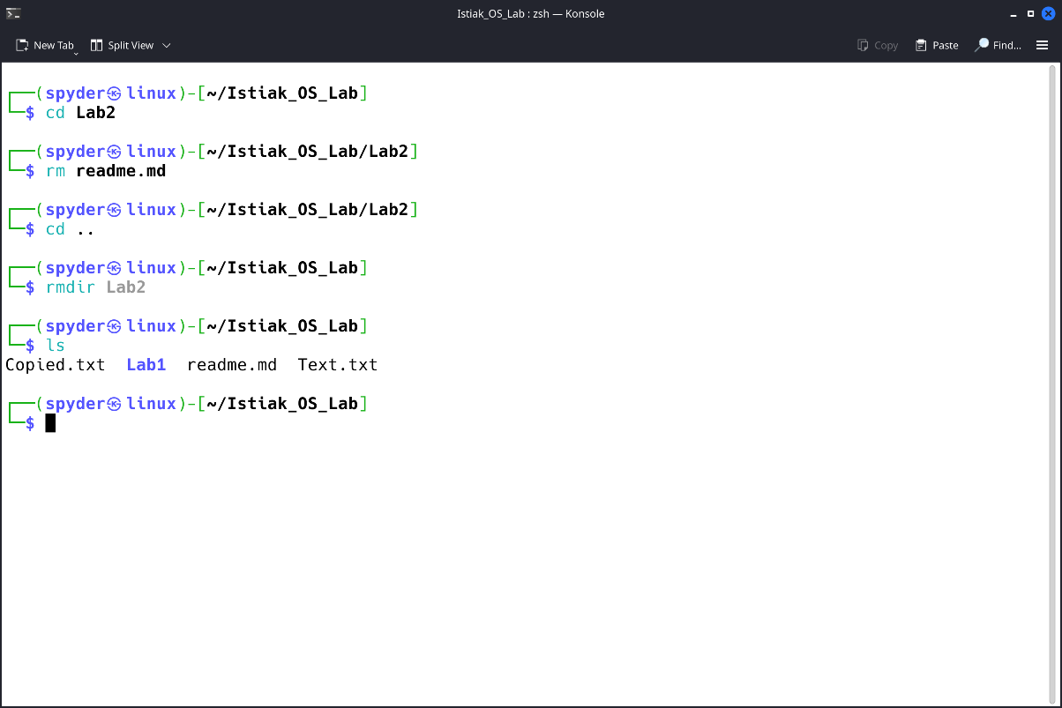

* 1. **Clear the contents of the terminal.**

Syntax : clear

Command : $ **clear**

Sample Input & Output :

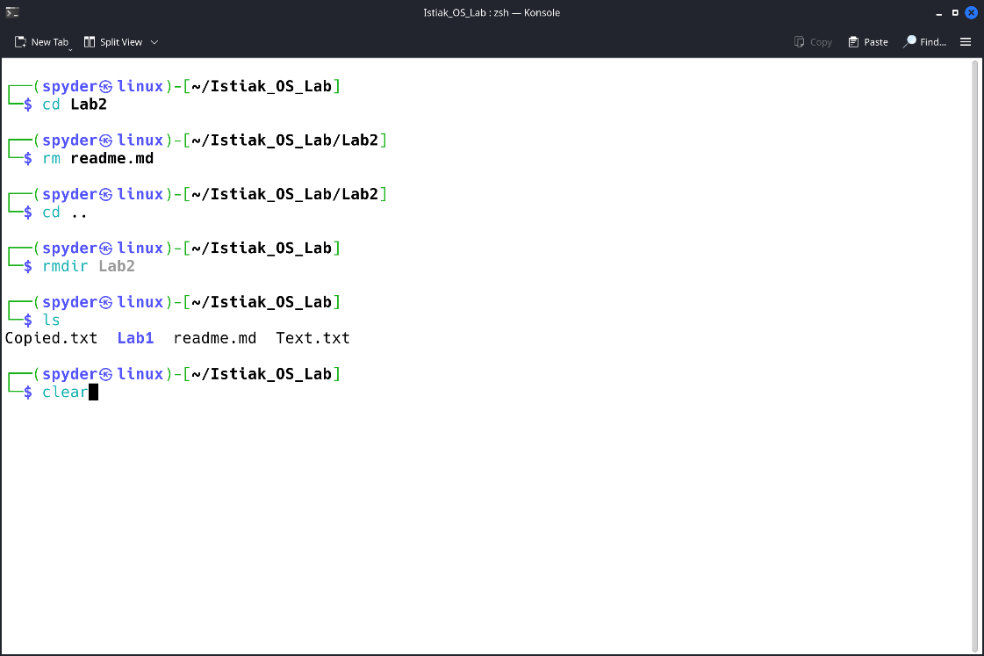

* 1. **View manual & help of specific command.**

Syntax : man Command_name

Command : $ **man touch**

Sample Input & Output :

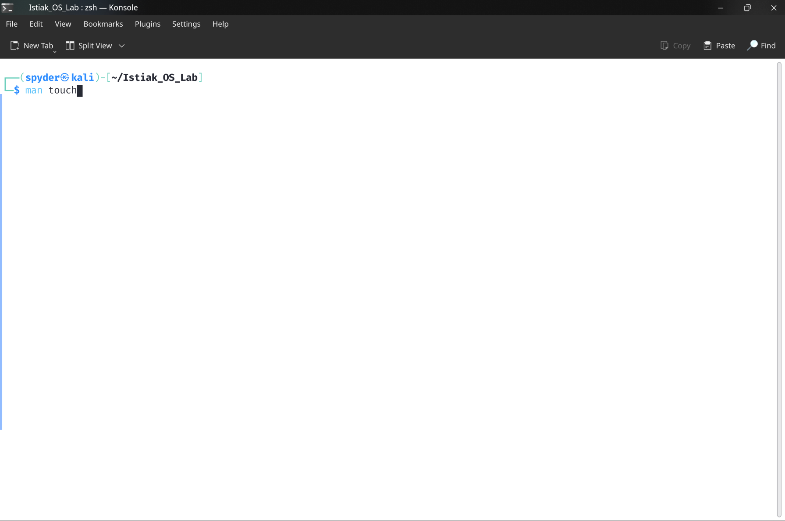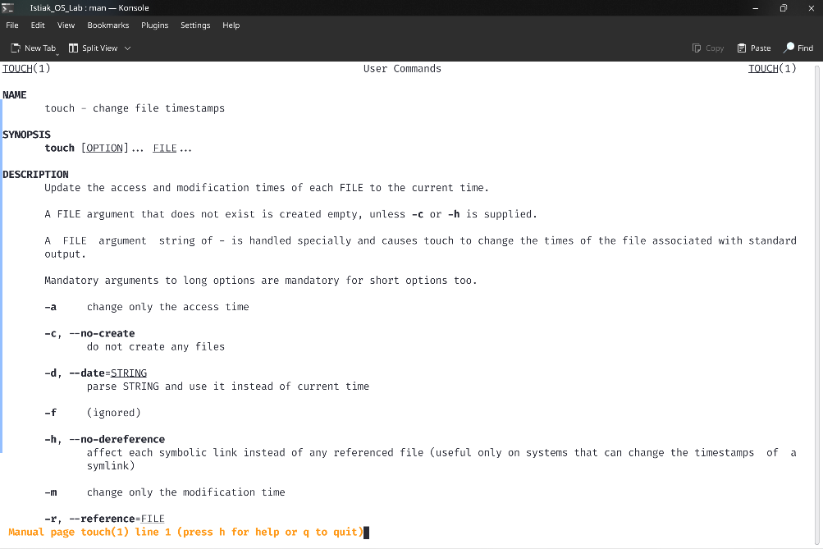

* 1. **Print** **list or display the contents of a directory in a tree like format.**

Syntax : tree directory_name

Command : $ **tree Arduino**

Sample Input & Output :

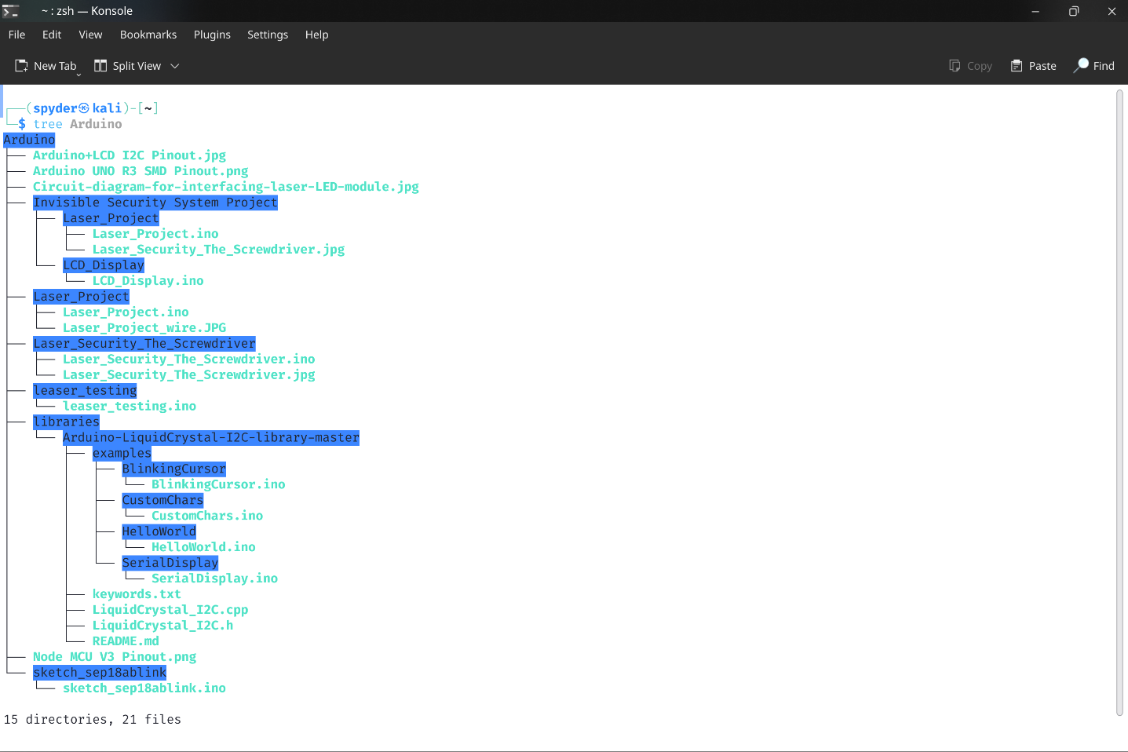

* 1. **Find files using terminal.**

Syntax : locate [options] file_name

Command : $ **locate -b art.jpg**

Sample Input & Output :

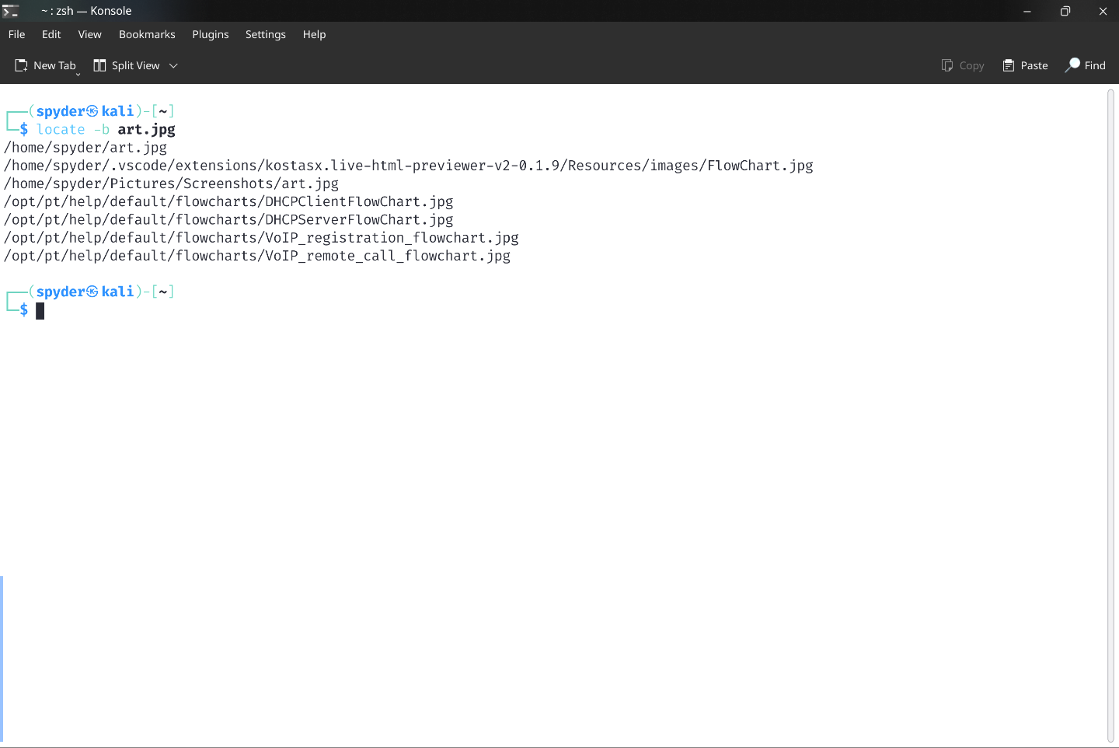

* 1. **Terminate a Process manually using terminal.**

Syntex : kill [option] pid

Command : $ **kill 2879**

Sample Input & Output :

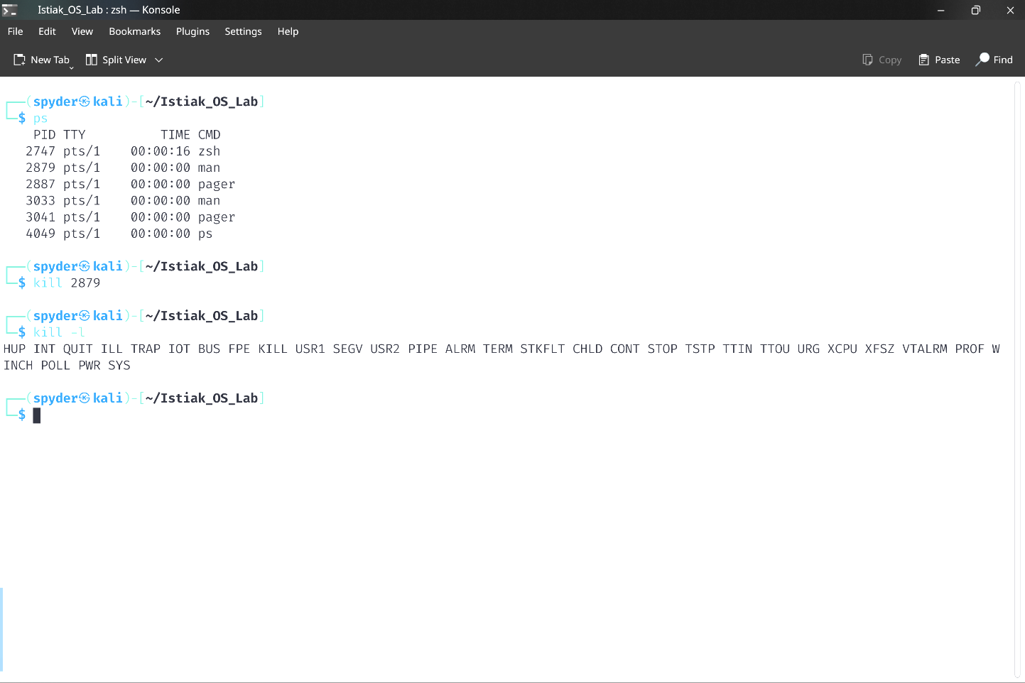

* 1. **Print Content of a file one scornful at a time using terminal**

Syntax : less file_name

Command : $ **less Text.txt**

Sample Input & Output :

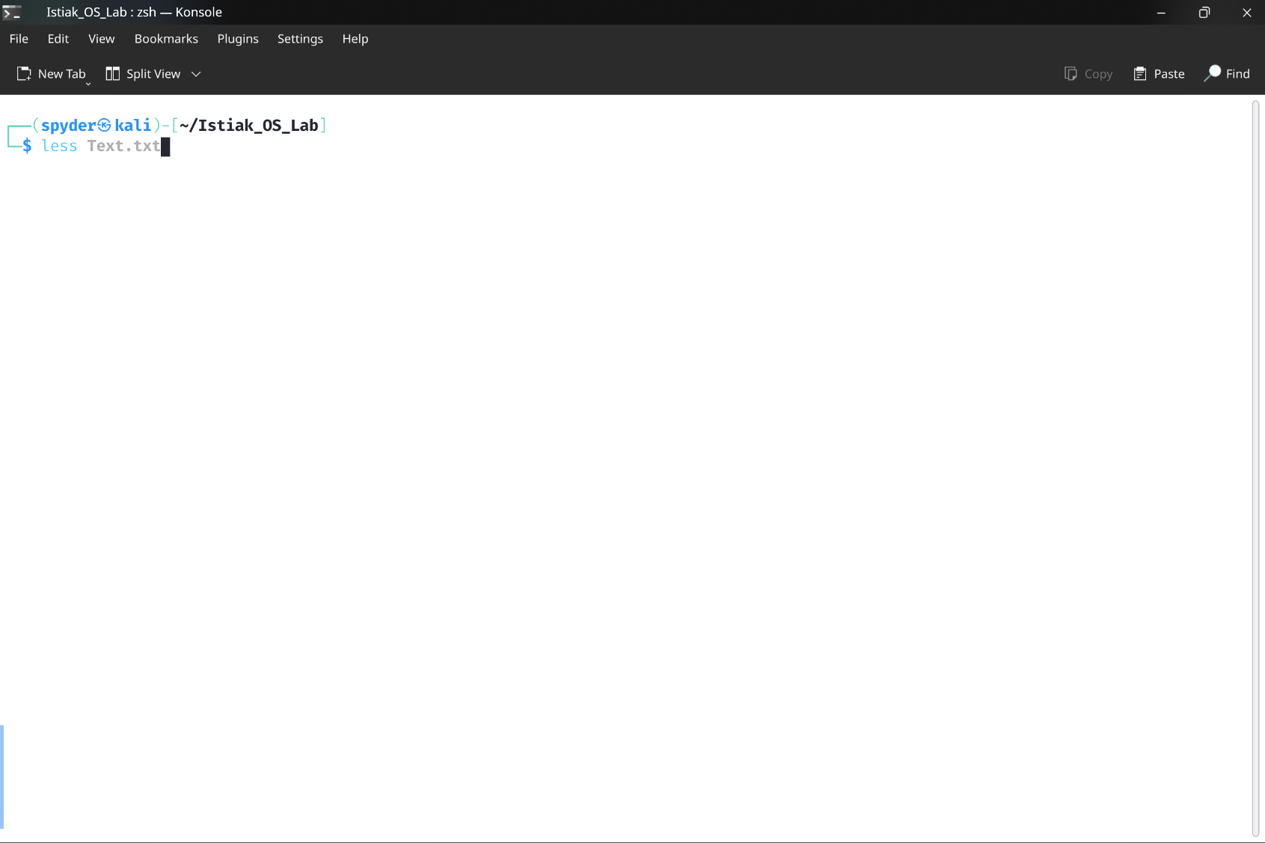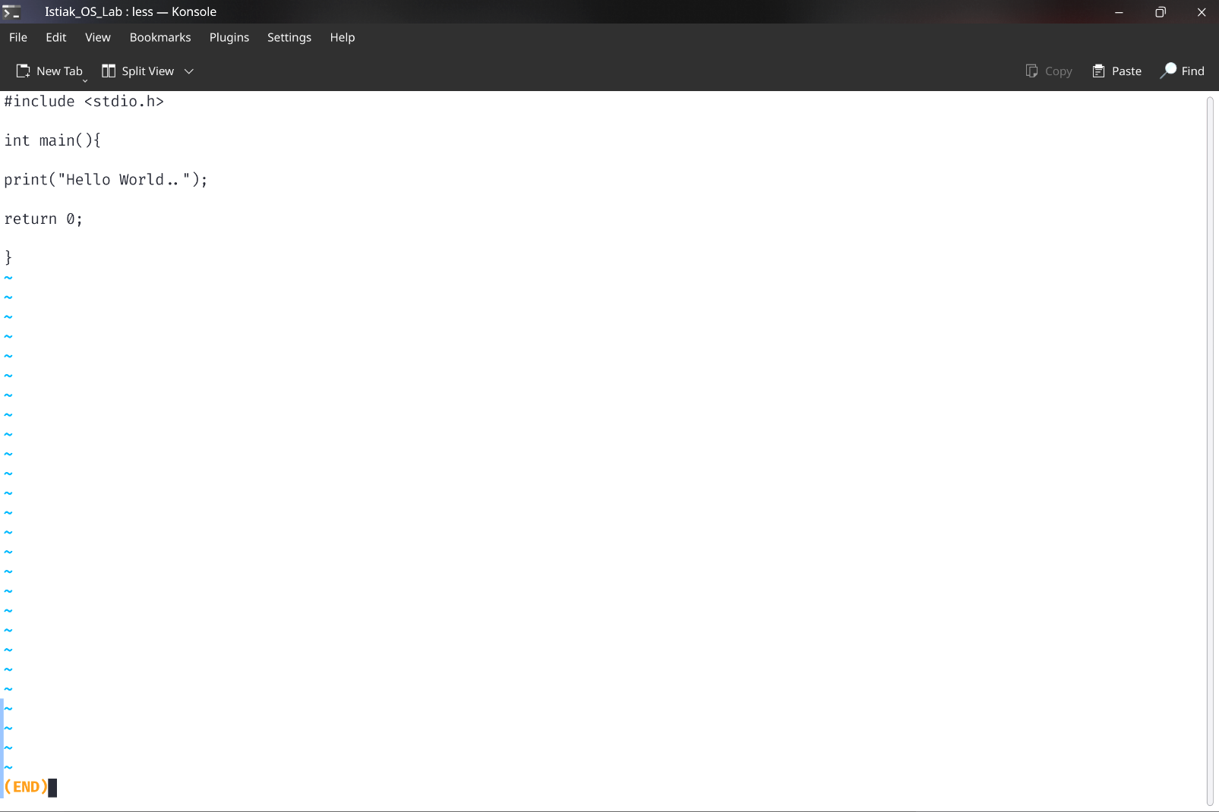

* 1. **Display username or who logged in.**

Syntax : who

Syntax : whoami

Sample Input & Output :

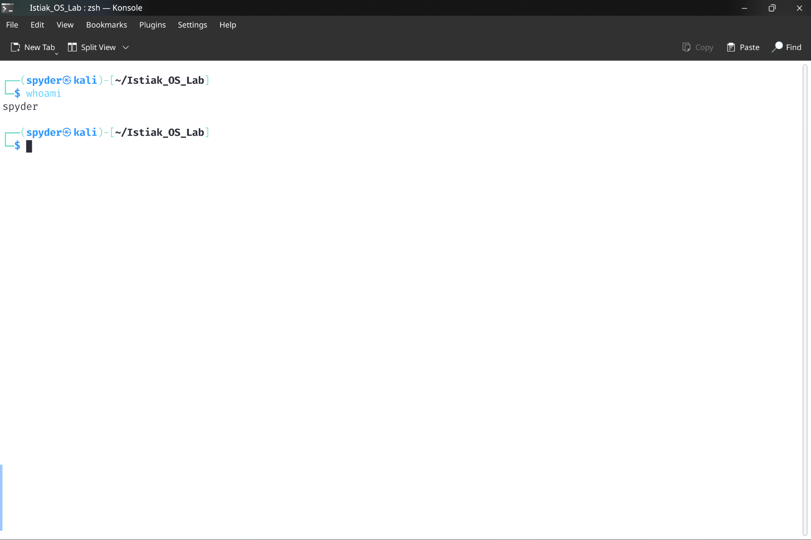

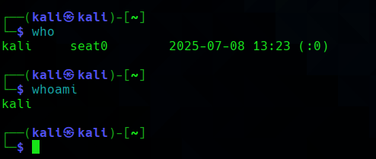

* 1. **Print the recourse being used in system using terminal**

Syntax : top

Command : $ **top**

Sample Input & Output :

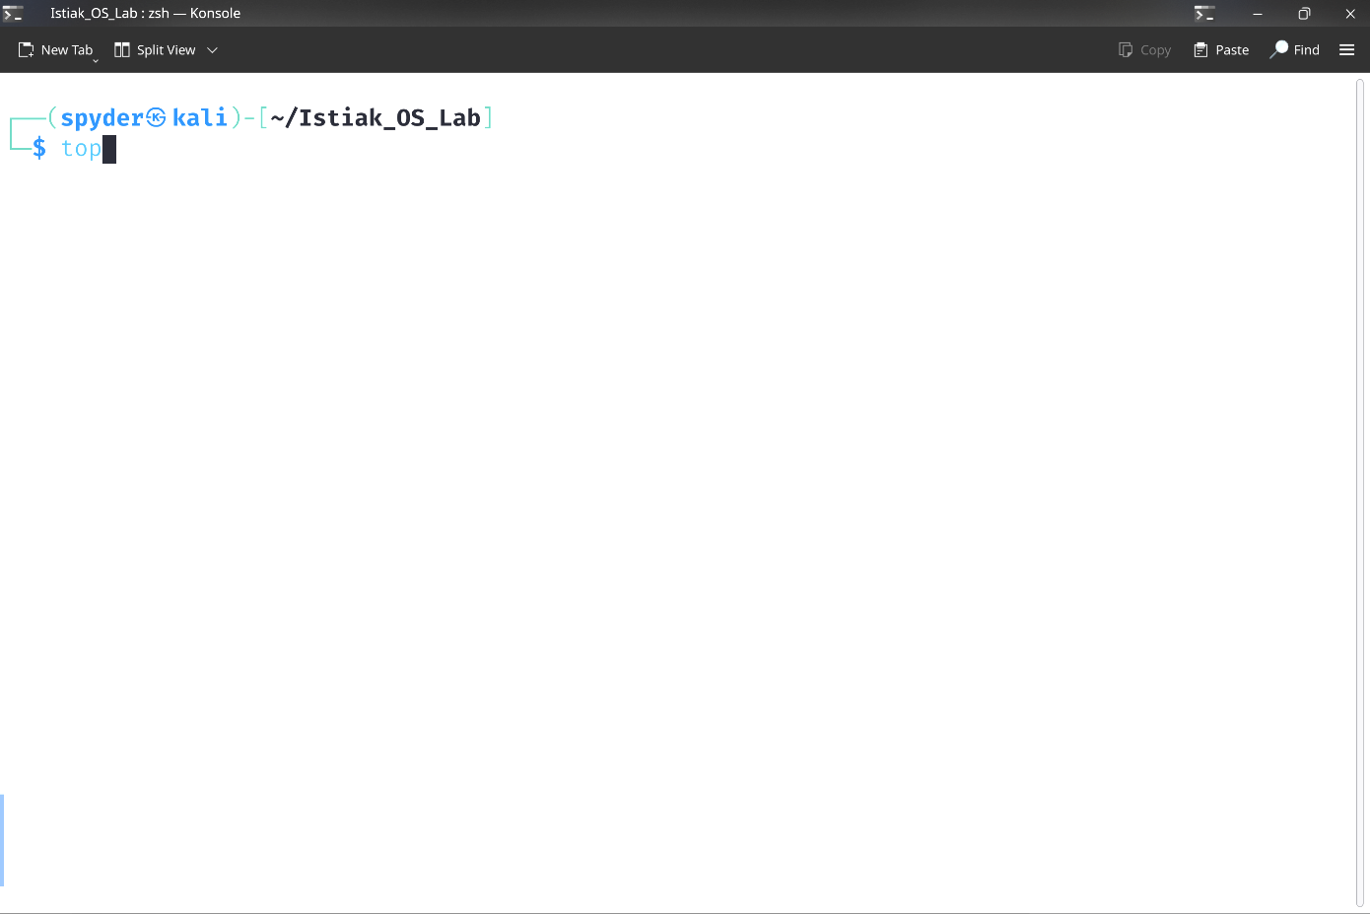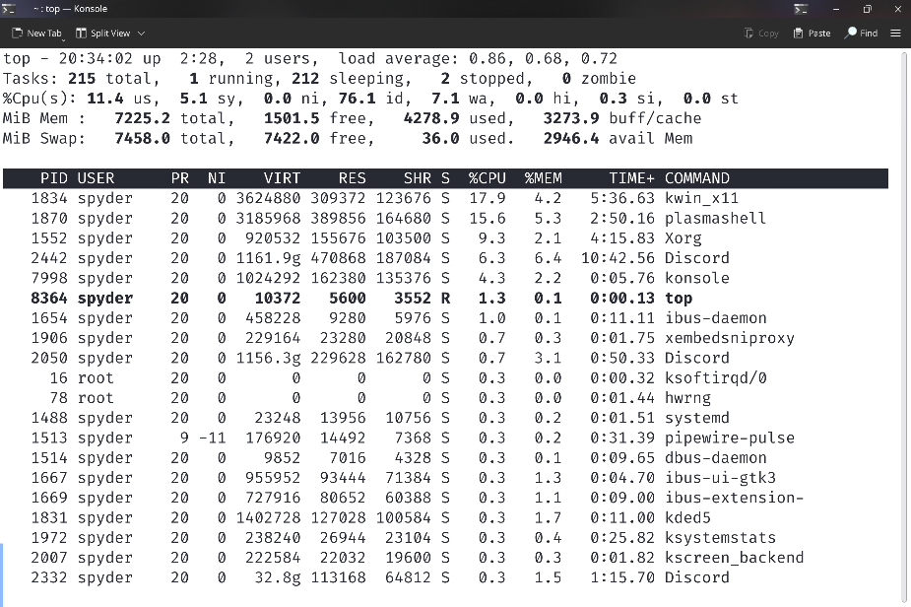

* 1. **Modify file access permissions using terminal.**

Syntax : chmod [options] permission_filename

Command : $ **chmod 111 Text.txt**

Sample Input & Output :

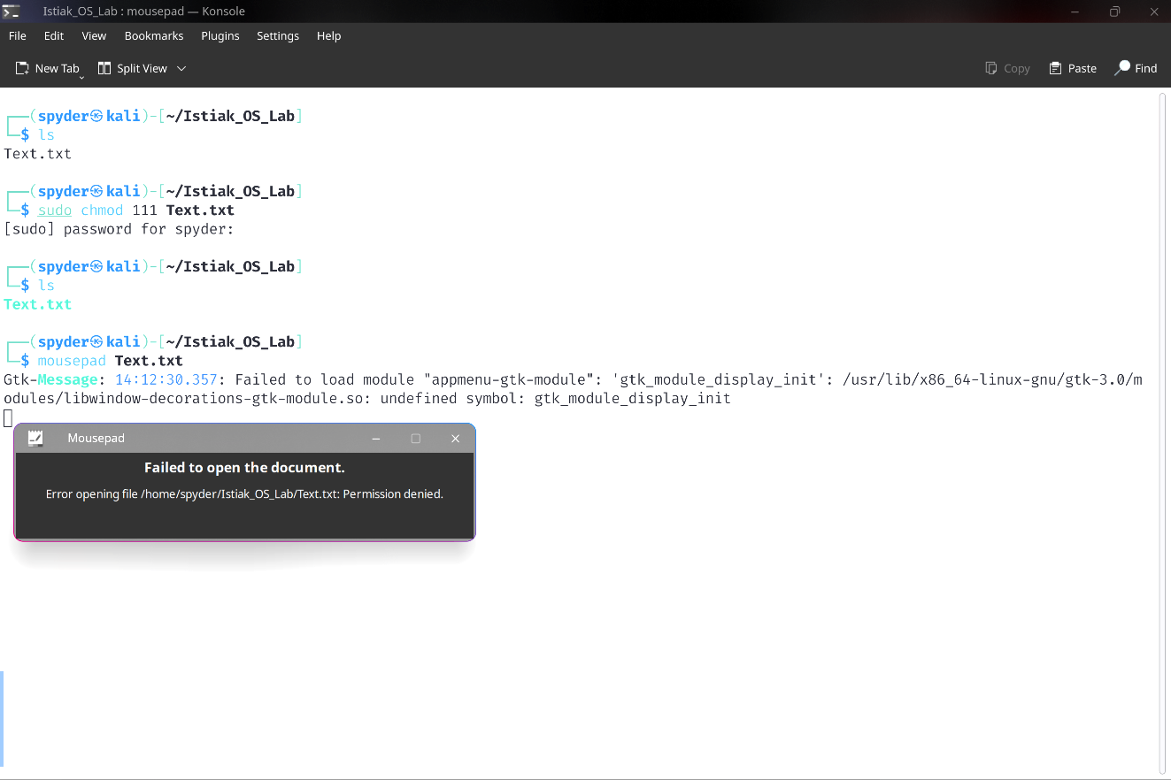

* 1. **Change the user and / or group ownership of a given file, directory or symbolic link using terminal.**

Syntax : chown [options] user [group] file_name

Command : $ **chown kali Text.txt**

Sample Input & Output :

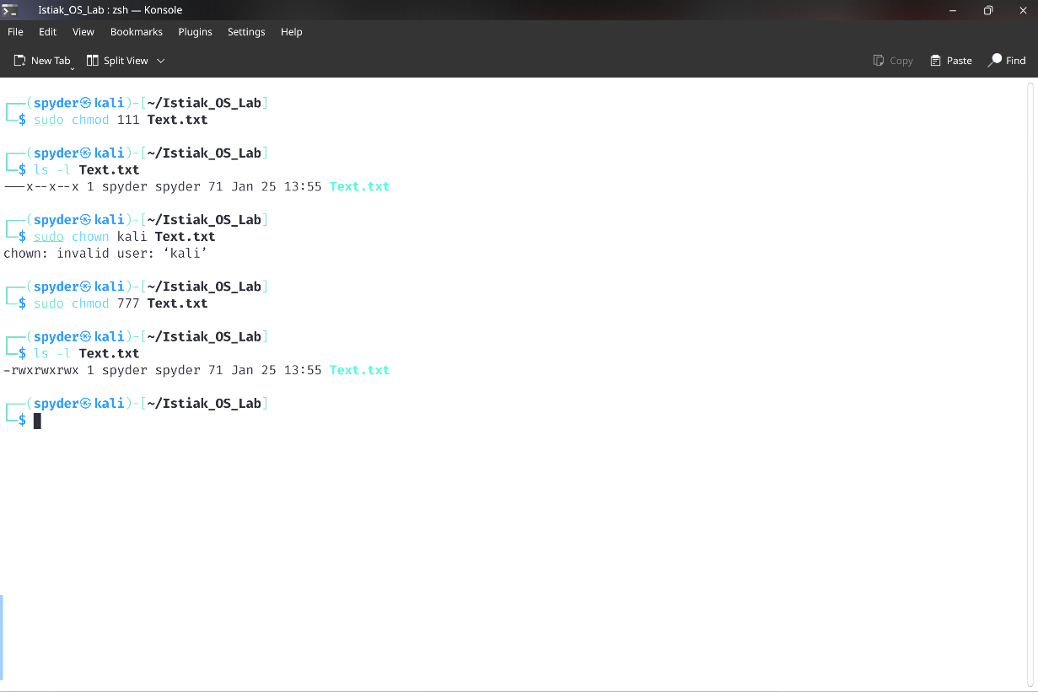

* 1. **Shows the size used and available space on the mounted file system.**

Syntax : df [option] file

Command : $ **df -h**

Sample Input & Output :

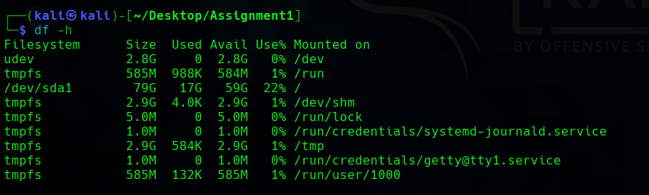

* 1. **Testing Internet Connection using Google DNS**

Syntax : ping [DNS server]

Command : **ping 8.8.8.8**

Sample Input & Output :

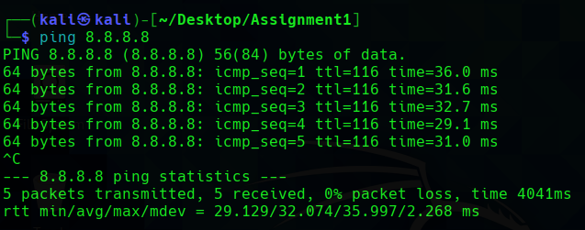

* 1. **Showing Commands History in terminal**

Syntax : history

Sample Input & output :

